1. Analysis of all the visualizations with respect to how it is helping you find the Key Performance Indicators and the causes of various problems identified.

**Dashboard 1: Job and Shipment Trends**

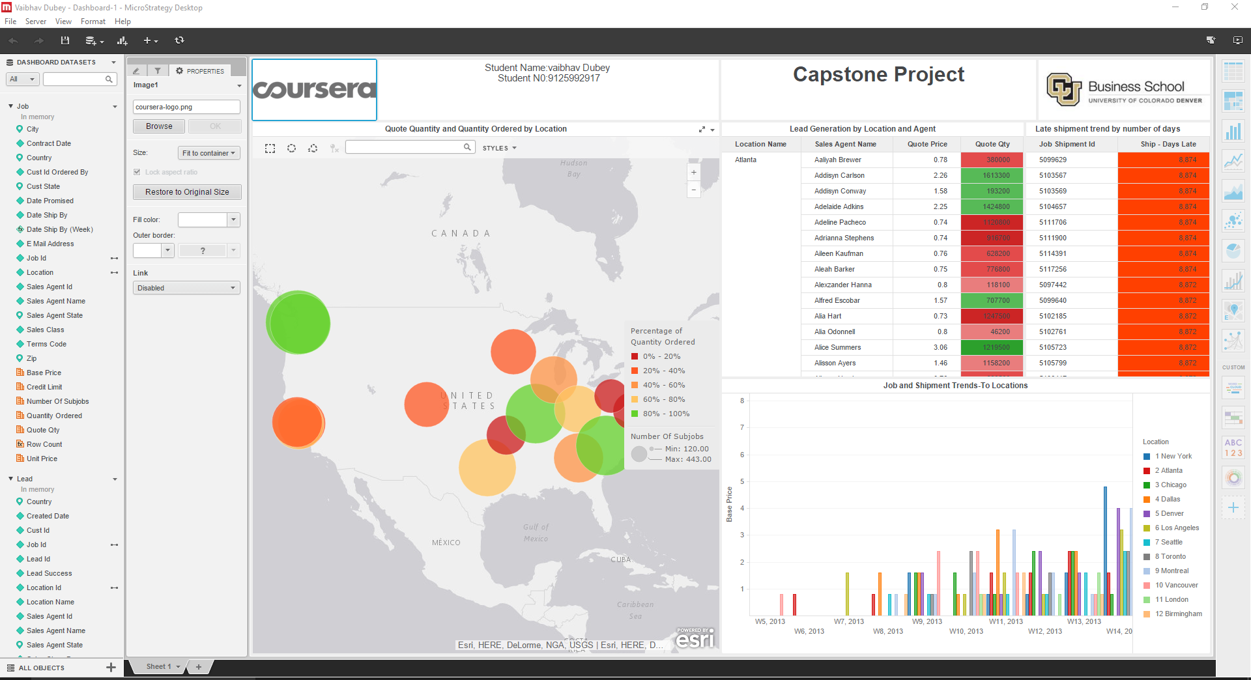

In the above Dashboard of Quote quantity and quantity by location, you can easily see in the map chart that we have derived the locations for zip codes, for a given particular location it is providing the information of quantity ordered and number of subjobs. In this Dashboard there is bubble chart in which bubble shows area bu quamtity ordered. There is also a visualization of Lead generation by location and agent,which depicts information about the Quote price and quantity by Sales agent for cities .The quote quantity in red denoted the lowest quote percentage for the particular city. In the Job and Shipment trends to Location, the bar chart displays information about the Ship dates by week for locations on basis of their base price. It is seen that the base price decreases by week in 2014. For Shipment days late, information is displayed about the days the shipment was delayed by for a particular Job Shipment id.

Questions:

1. How many jobs does each sales agent book?
   1. 25
2. How many jobs have not yet shipped or have only partially shipped?
   1. 396331

**Dashboard 2: Invoice Trends**

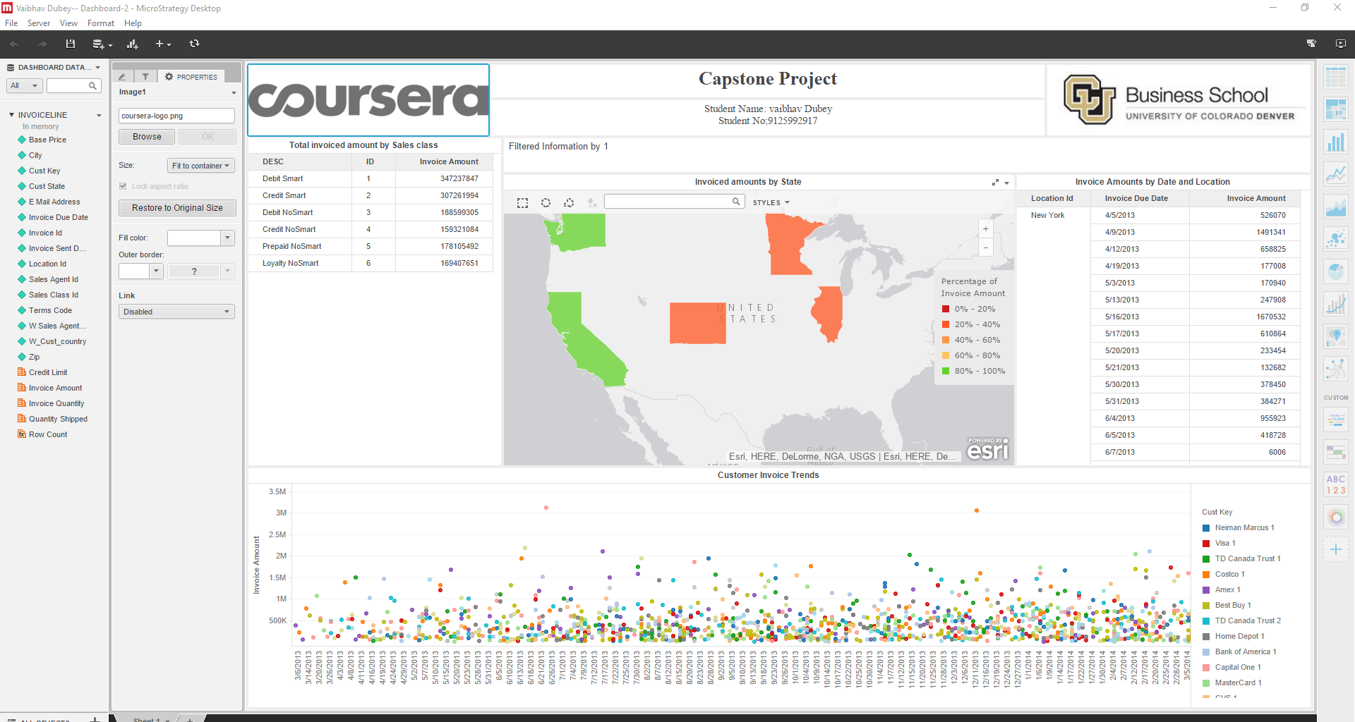

This grid data shows information about the invoice amount for the Sales class Id for four different types of cards generated by CPI Inc. The invoice amount by state shows us the regions in United States by the invoice amounts. The regions showing green color have the highest invoice amount and the ones with red have the lowest. Customer invoice trends displays information about the invoice amount by the invoice due dates with correspondence to the customer keys. This graph displays the information about the Customer Invoice Amount trends by Invoice due dates and the reflecting Invoice amount which helps us understand how the Invoice amount changes over the period of time for each customer. Invoice amounts by date and location, similar to the previous graph, shows grid data information about the due dates for Invoice amount by the location id.

Questions:

1. Which sales class generate the highest invoice amounts?
   1. Debit Smart
2. How many invoices are generated for a time period?
   1. 1319363326
3. What is the total amount invoiced for a time period?
   1. 1349933373

**Dashboard 3: Financial Performance**

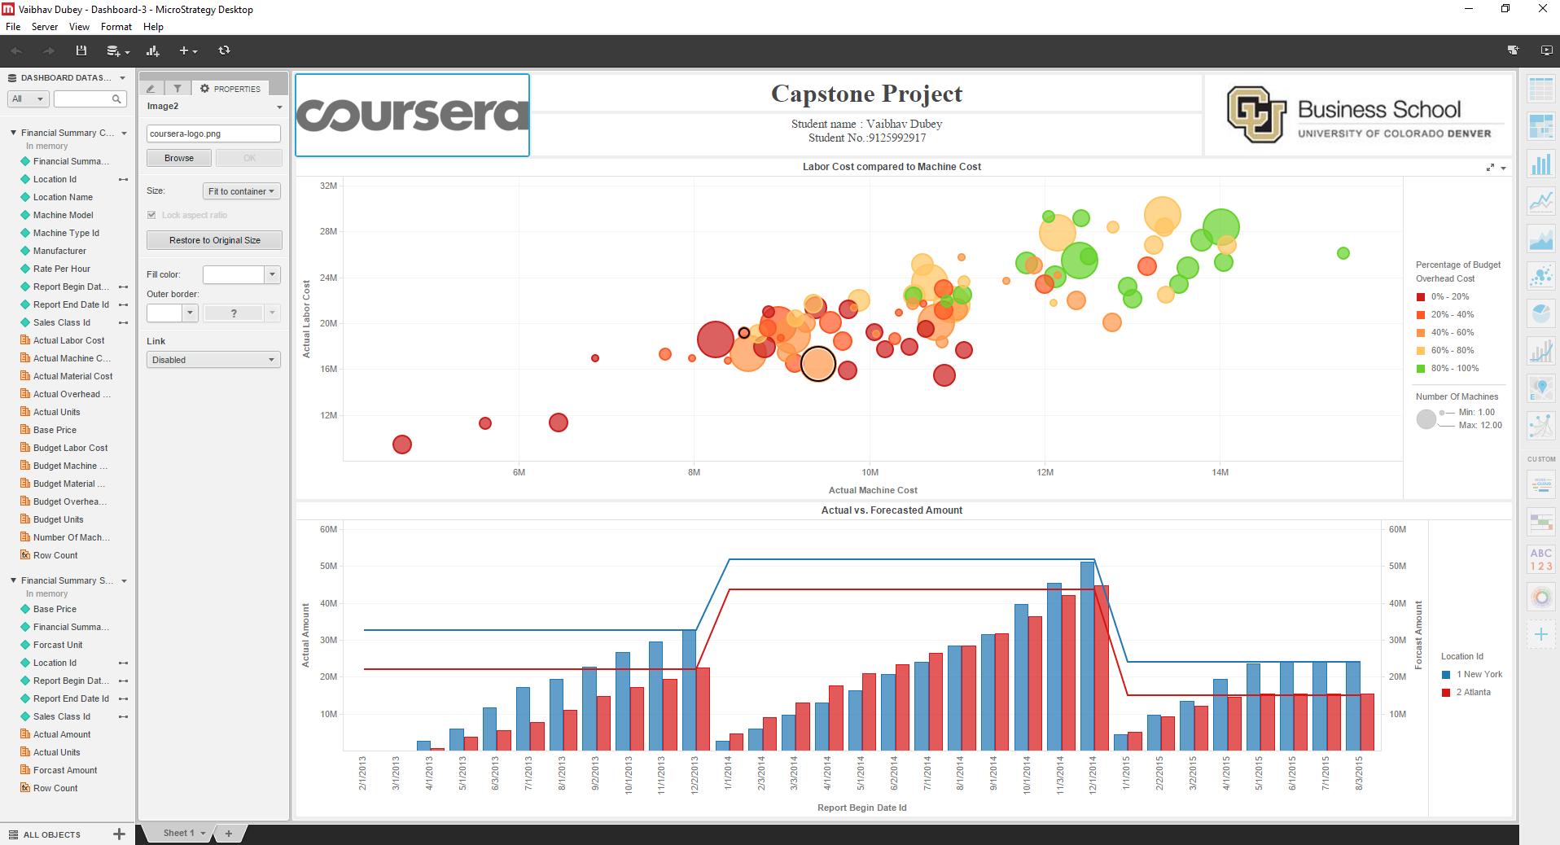

From the above bubble chart it is seen how the budget overhead cost compares in relation to the Actual machine cost and Actual labor cost. The below graph reflects the changes for the bubbles in relation with the machine type and location. The bubbles in red shows the lowest budget overhead cost and the ones in green show higher overhead budget cost. Conclusion: From this analysis, we understand the key performance indicators of the CPI Company and the profit it has generated over the time period for

particular regions. The job and shipment trends, invoice trends and the financial summary give us an overall idea about the CPI growth and also tells about the areas they need to improve on.

Question:

1. Determine the location and the machine which have the highest overall machine and labour cost. Also, determine which location has the lowest budget overhead cost.
   1. Seatle
   2. Atlanta
2. Which location is seen to have higher forecast amount in comparison to the actual amount on the basis of time period?
   1. Vancouver